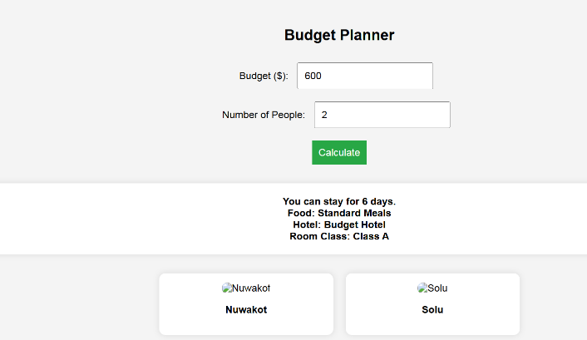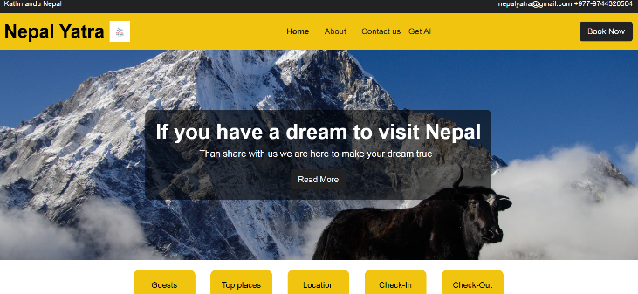 About Us :

**Bookmundi** – Provides Nepal tour packages and budget-friendly travel recommendations.

**Competitors**

This one page shows the overview of Nepal yatra highlighting the company mission and vision, its global presence, website developing cost ,snapshots and how it helps the tourist to find their destination according to budget and increase the economy of local business

Snaps Shots

Comisson from hotel and cloud kitcen

We continue to expand our user base and partnerships with travel agencies and businesses.

**Profitable market share gains**

Our estimated cost for marketing and branding is Rs 20000- 50000

**After lunching the project in real field**

Domain and hosting up to RS 5000 - 15000

Development cost up to 1 lakh

Before lunching the project

**FINANCIAL PROGRESS TO DEVELOP THE WEB SIDE AND AFTER LUNCHING PROJECT IN PRATICAL FIELD**

To provide users with personalized travel recommendations based on their budget and preferences, ensuring a hassle-free and memorable experience.

**Misssion and Values**

**Mission**

Nepal Yatra is a travel platform designed to help users explore destinations based on their budget and preferences.Our goal is to simplify trip planning and enhance user experience through an AI-driven platform and larveging the local business and local product

**One pager**

**Nepal yatra Annual Report**